 | BAU | No SHS growth | BAU + Low-income capital subsidy | BAU + Low-income FIT/monthly credit | BAU + Low-income zero-interest loan
Low-income SHS adoption | None | None |  | None
Middle-income SHS adoption | 20% by 2050 (S shape?) | Stays at 2024 adoption rate (1%) until 2050 |  | 50% by 2050
High-income SHS adoption | 20% by 2040 (S shape?) | Stays at 2024 adoption rate (8%) until 2050 |  | 50% by 2040

African Power Equipment
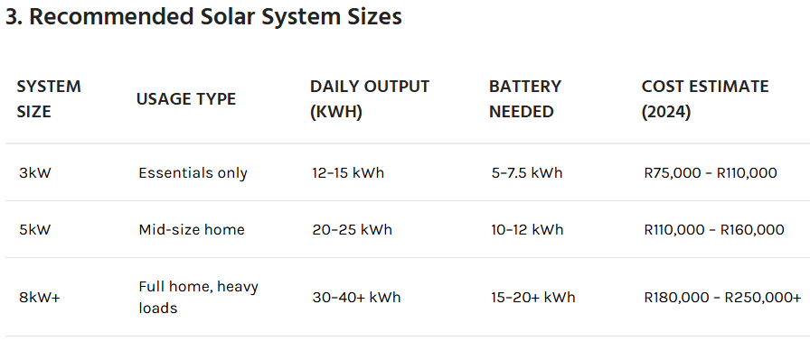
City of Cape Town: most households have 2kWp-8kWp. 40-100% of the electricity for an SHS household comes from SHS

 | BAU | No SHS growth | BAU + Low-income capital subsidy | BAU + Low-income FIT/monthly credit | BAU + Low-income zero-interest loan
Capital Cost (ZAR/MW) | 20 | 20 | 20 | 20 | 20
Capital Subsidy (%) | 0 | 0 | 30 | 0 | 0
Loan Term (years) | 5 | 5 | 5 | 5 | 5
Loan Interest (%) | 10 | 10 | 10 | 10 | 0
Monthly Credit ($/month) | 0 | 0 | 0 | 10 | 0
FIT ($/kWh) (negative variable cost) | 0 | 0 | 0 | X | 0
High-income SHS adoption
Middle-income SHS adoption
Low-income SHS adoption | 0 | 0

Effective Capital Cost ($/kW):
$Capital Cost * (1 - Capital Subsidy / 100)$

Annual Capital Payment ($/kW-yr):
If $Loan Interest Rate = 0,$
$Annual Capital Payment \left(\frac{\$}{kW∙yr}\right)=\frac{ Effective Capital Cost }{Loan Term},$
If $Loan Interest Rate> 0,$
$Annual Capital Payment \left(\frac{\$}{kW∙yr}\right)=Effective Capital Cost * \frac{Loan Interest Rate{\left(1 +Loan Interest Rate\right)}^{Loan Term}}{{\left(1 + Loan Interest Rate\right)}^{Loan Term} - 1}$
Annual Credit Received:
$Monthly Credit * 12$
Net Annual Cost (after credit applied)
$Annual Capital Payment - (Monthly Credit * 12)$

https://www.awpower.co.za/wp-content/uploads/AWPower-Standard-Battery-Backup-Solutions-Updated-15-April-2025.pdf
- 5 kW system with battery: starting at R69 500
$$\frac{R70 000}{5 kW}=R14 000/kW$$

https://wise.com/us/currency-converter/zar-to-usd-rate?amount=14000
R1.000 ZAR = $0.05609 USD
R14 000 = 785.30 USD
Capital cost 20 000 ZAR per kW: https://solarsquare.co.za/how-much-do-solar-panels-cost-in-south-africa/#:~:text=A%20basic%201%2D2%20kW%20system%2C%20suitable%20for,estimated%20to%20cost%20between%20R180%2C000%20and%20R220%2C000%E2%80%8B.

SA interest rates: https://tradingeconomics.com/south-africa/interest-rate
Low-income adoption rates
- BAU + Low-Income FIT/Monthly Credit: There is still the upfront capital cost barrier. An FIT/Monthly Credit increases financial return and lowers energy payback time. Size of credit determines effectiveness. Low-income adoption rate is moderate
- BAU + Low-Income Capital Subsidy: Main barrier to SHS adoption is the high upfront costs (shown in literature). A large subsidy can significantly increase adoption rate. Low-income adoption is high.
- BAU + Low-Income Zero-Interest Loan. Allows households to spread upfront costs over time without paying additional interest. This can lead to higher adoption than a capital subsidy if the period of repayment is long enough.
Feed-in (residential):

2017/2018
2018/2019
2019/2020
2020/2021
2021/2022
2022/2023
2023/2024
2024/2025
2025/2026

- 2017/2018
  - Feed-in: 79.22
- 2018/2019
  - Feed-in: 84.95
- 2019/2020
  - Feed-in:
    - Tariff1: 84.95
    - Tariff2:78.79
- 2020/2021
  - Feed-in: 84.23
  - Incentive: 28.75
- 2021/2022
  - Feed-in: 84.23
  - Incentive: 28.75
- 2022/2023
  - Feed-in: 90.83
  - Incentive: 28.75
- 2023/2024
  - Feed-in: 100.05
  - Incentive: 28.75 (Until June 30 2025)
Feed-in (non-residential)
- 2017/2018
  - Feed-in (This tariff is available only for approved nonresidential SSEG Connections, where the Customers offset their small scale generation against their purchases from the Municipality, provided that their purchases exceed their generation. An additional meter reading fee may also be applicable. This is not applicable to Customers on the SPU2 tariff.): 79.22
- 2018/2019
  - Feed-in (This tariff is available only for approved nonresidential SSEG Connections, where the Customers offset their small scale generation against their purchases from the Municipality, provided that their purchases exceed their generation. An additional meter reading fee may also be applicable. This is not applicable to Customers on the SPU2 tariff.):: 84.95
- 2019/2020
  - Feed-in
    - Tariff 1: 84.95
    - Tariff 2: NEW
- 2020/2021
  - Feed-in
    - Tariff 1: 84.95
    - Tariff 2: 71.81
  - Incentive: 28.75
- 2021/2022
  - Feed-in:
    - Tariff 1(Rate at which excess energy generated onto the grid will be purchased, unless Tariff 2 is exercised. Green attributes will transfer to the City) 84.95
    - Tariff 2(To be paid to customers who wish to retain/claim the green attributes of the energy exported and sold to the City.) 71.81
  - Incentive: 28.75
- 2022/2023
  - Feed-in:
    - Tariff 1(Rate at which excess energy generated onto the grid will be purchased, unless Tariff 2 is exercised. Green attributes will transfer to the City) 84.95
    - Tariff 2(To be paid to customers who wish to retain/claim the green attributes of the energy exported and sold to the City.) 70.05
  - Incentive: 28.75
- 2023/2024
  - Feed-in:
    - Tariff 1(Rate at which excess energy generated onto the grid will be purchased, unless Tariff 2 is exercised. Green attributes will transfer to the City) 89.11
    - Tariff 2(To be paid to customers who wish to retain/claim the green attributes of the energy exported and sold to the City.) 72.66
  - Incentive: 28.75

https://resource.capetown.gov.za/documentcentre/Documents/Financial%20documents/Budget_2023-24_Ann6_TariffsFeesandCharges.pdf
https://resource.capetown.gov.za/documentcentre/Documents/Financial%20documents/Ann6_2021-22_ElectricityGenerationandDistribution-Consumptive.pdf

BAU | No SHS Growth
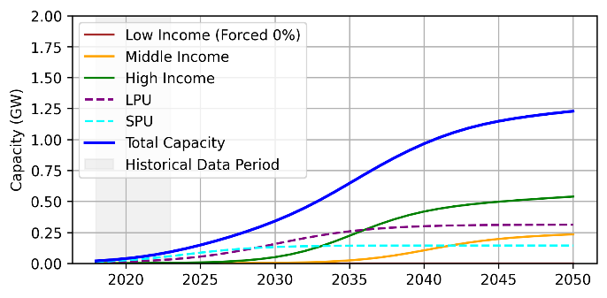  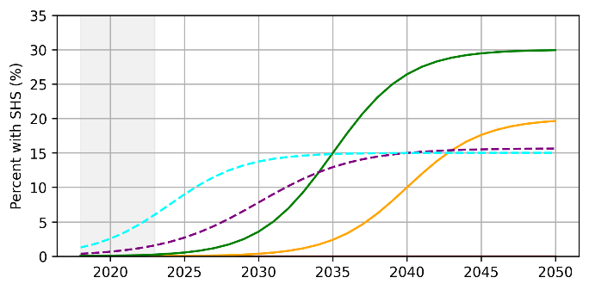 | 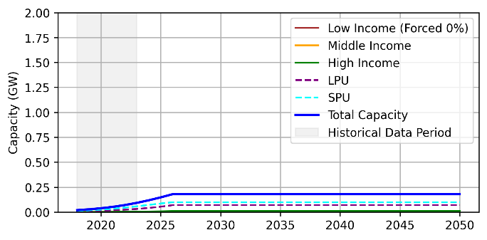  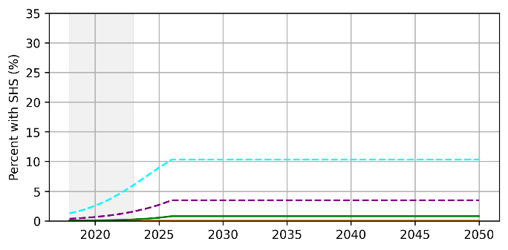
BAU + Low-income capital subsidy | BAU + Low-income FIT/monthly credit & BAU + Low-income zero-interest loan
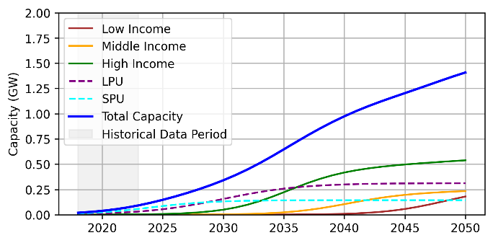  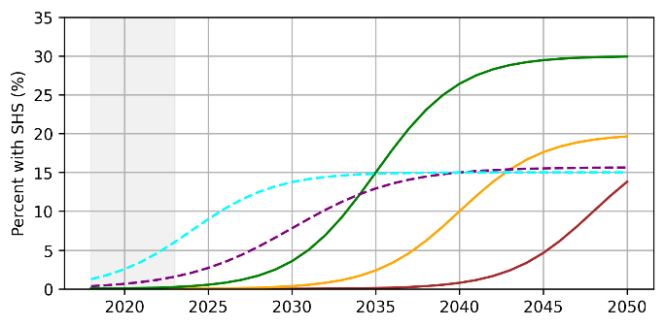 | 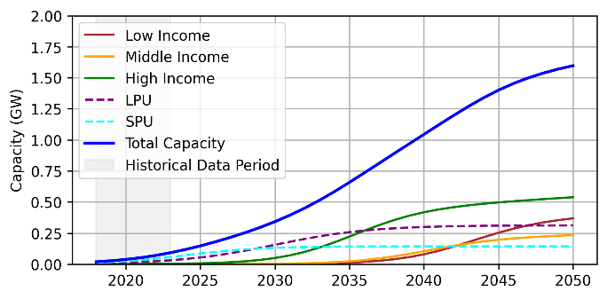  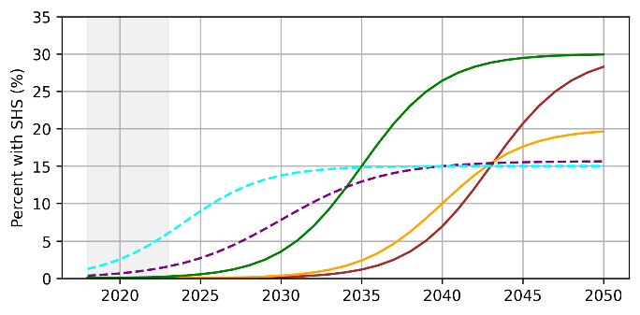

BAU
SHS adoption rates are projected starting in 2024 using an S-curve:
$S\left(t\right)=\frac{L}{1+\exp\left(-4∙\frac{t-t_{mid}}{width}\right)}$
Middle- and high-income SHS adoption rates are capped at 20% and 30%, respectively. The midpoints for the high-income adoption curve are 2035 and 2040 for middle-income households. Low-income households have a 0% adoption rate over time.
SHS capacity is calculated as follows:
$Capacity=Households×Adoption rate×System size$
where the average system size varies for each household type:
- Low-income: 3kW
- Middle-income: 5kW
- High-income: 8kW
An S-curve is also used to project adoption rates for LPUs and SPUs. Future capacity is calculated starting from historical consumption values, which is converted to capacity using:
$$Capacity=\frac{Energy}{CF×Hours per year}$$
where the capacity factor ($CF$) is $19.6\%$.
No SHS Growth: SHS capacity and adoption rates do not grow past 2026.
BAU + Low-income capital subsidy: The low-income household adoption rate is defined with the same s-curve parameters as the middle-income adoption rate (capped at 20%), just delayed by 8 years.
BAU + Low-income FIT/monthly credit: The low-income household adoption rate is defined with the same s-curve parameters as the high-income adoption rate (capped at 30%), just delayed by 8 years.
BAU + Low-income zero-interest loan: The low-income household adoption rate is defined with the same s-curve parameters as the high-income adoption rate (capped at 30%), just delayed by 8 years.

The adoption rate for technological innovations tends to follow an s-curve, which defines slower, early adoption among a small subpopulation, with rapid uptake towards a saturation point, where the adoption rate begins to level out (Ayres 1992; Rogers 2003; Schilling et. al 2009). Similar adoption patterns for solar home systems are used in previous literature on solar home system adoption (Mejia et. Al 2024; Batista da Silva et al. 2020). In this paper, we define adoption patterns for each household income group using an s-curve, defined as:
$$A\left(t\right)=\frac{S}{1+e^{-k(t-t_{0})}}$$
Where $A\left(t\right)$ represents cumulative adoption at time $t$, $S$ is the maximum market saturation rate, $k$ is the growth rate, $t_{0}$ is the inflection point, and $e$ is Euler’s number. In the BAU scenario, middle- and high-income SHS adoption rates are capped at 20% and 30%, respectively. The midpoint for the high-income adoption curve is 2035 and 2040 for middle-income households. Low-income households have a 0% adoption rate over time.
SHS adoption for SPUs and LPUs is also estimated using an s-curve, which caps adoption at 15% by 2040 (City of Cape Town & SEA, 2015).
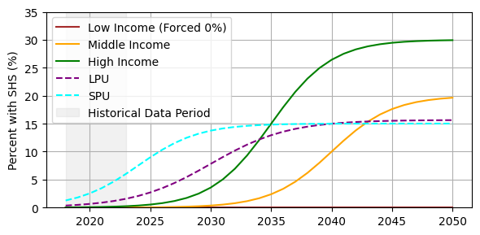
The average size of a solar home system for each income group is considered to estimate total SHS capacity for households. For low-income households, the average SHS size is 3kW, 5kW for middle-income households, and 8kW for high-income households. A 3kW system can be used to power essential appliances only, while a 5kW can power an average-sized home, and an 8kW system can power a larger home with energy-intensive appliances (Africa Power Equipment). SHS capacity is then calculated as follows:
$$Capacity=Households×Adoption rate×System size$$
Future capacity for SPUs and LPUs is calculated starting from historical consumption values, which are converted to capacity using:
$$Capacity=\frac{Energy}{CF×Hours per year}$$
where the capacity factor ($CF$) is $19.6\%$ (Cape Town SOEC report 2021).
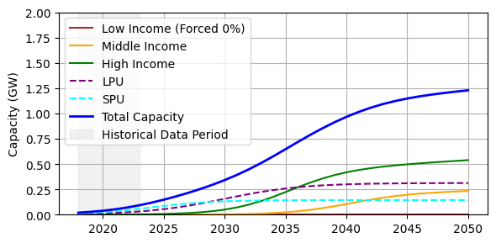

Rogers, E. M. (2003). Diffusion of Innovations (5th ed.). Free Press.
Mejia 2024: Spatiotemporal Estimation of the Potential Adoption of Photovoltaic Systems on Urban Residential Roofs
Batista da Silva et al: Market diffusion of household PV systems: Insights using the Bass model and solar water heaters market data
Schilling, M.A., Esmundo, M., Technology S-curves in renewable energy alternatives: Analysis and implications for industry and government. Energy Policy (2009), doi:10.1016/j.enpol.2009.01.004
Ayres: Toward a non-linear dynamics of technological progress

